* **Department: engineering mathematics and physics**
* **Academic year:2020/2019 preparatory**
* **Name: عبد الرحمن عيد سيد محمد قاسم**
* **B.N: 456**
* **Topic: mobile computing**
* **Date:2/7/2020**
* **GitHub link:** [**https://github.com/abdelrahman-eid/ECE006**](https://github.com/abdelrahman-eid/ECE006)
* **GitHub page:**  [**http://abdelrahman-eid.github.io/ECE006/**](http://abdelrahman-eid.github.io/ECE006/)
* **E.mail:** [**abdelrahman195511@feng.bu.edu.eg**](mailto:abdelrahman195511@feng.bu.edu.eg)

**.Application brief**

* **Mobile Computing is a technology that allows transmission of data, voice and video via a computer or any other wireless enabled device without having to be connected to a fixed physical link. The main concept involves**
* **Mobile communication**
* **Mobile hardware**
* **Mobile software**
* **Advantages**

**1- Increase in Productivity- Mobile devices can be used out in the field of various companies, therefore reducing the time and cost for clients and themselves.**

* **Disadvantages:**

**1- Quality of connectivity- as one of the disadvantages, mobile devices will need either WiFi connectivity or mobile network connectivity such as GPRS, 3G and in some countries even 4G connectivity  that is why this is a disadvantage because if you are not near any of these connections your access to the internet is very limited.**

* **Application**

**Networks**

**Wired network has been replaced in wireless network e.g. trade shows, remote sensors and historical buildings. in wired networks, weather forecasting, earthquake detection and to get environmental data are impossible. This is possible only in adapting the replacement of fixed networks in this computing**

**Screenshots:**

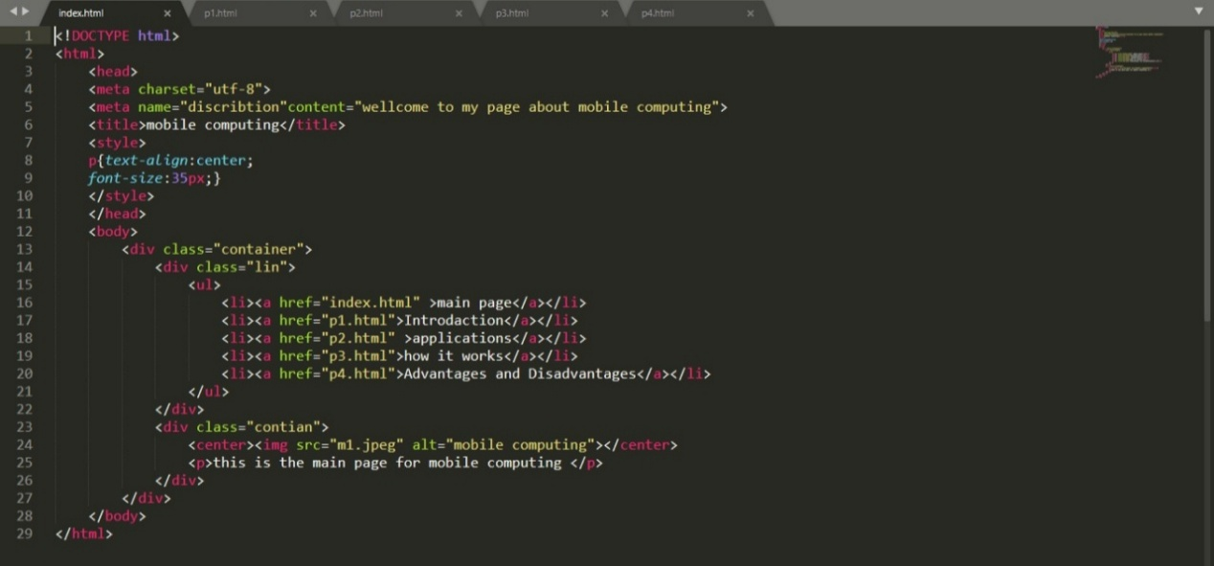

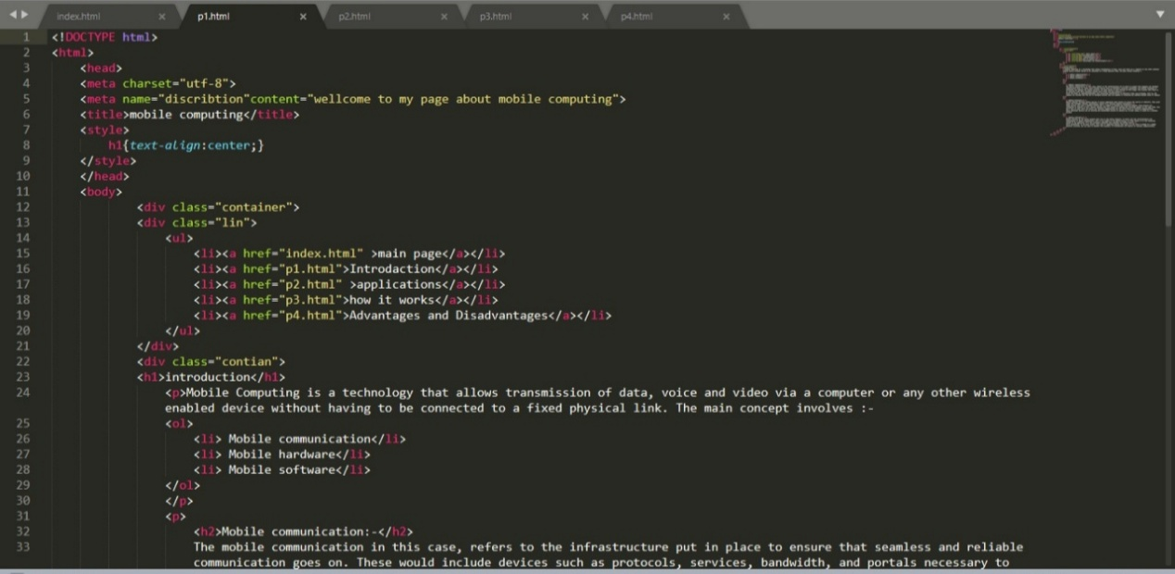

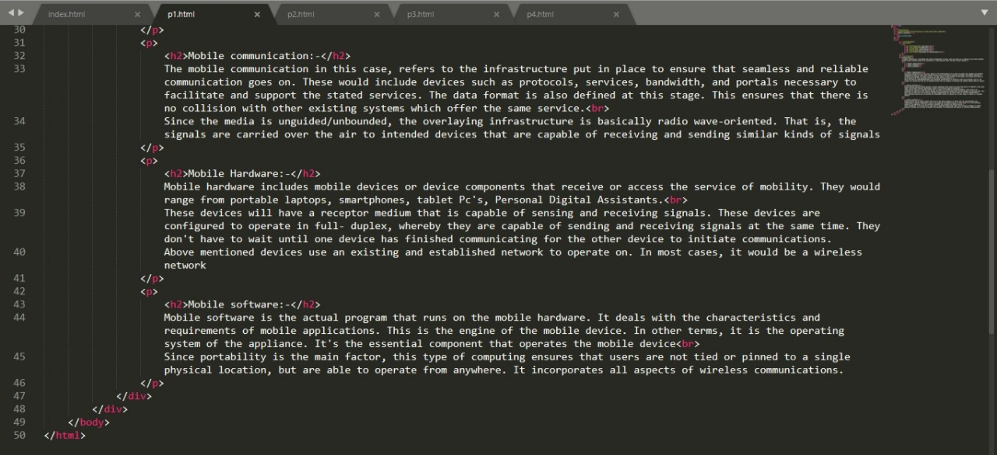

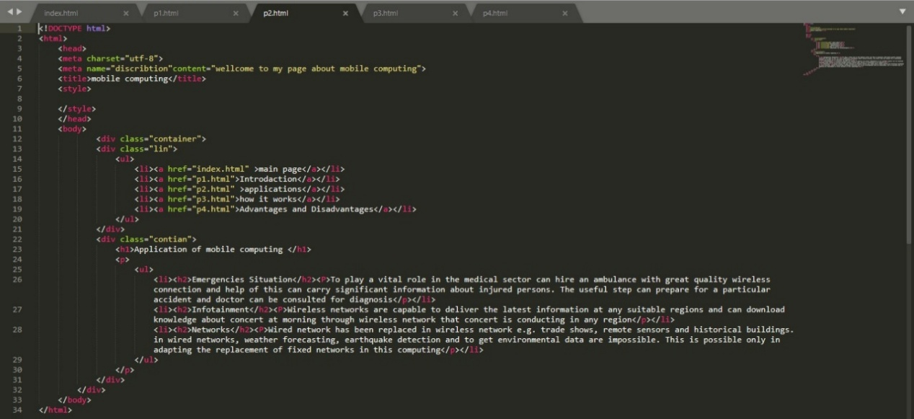

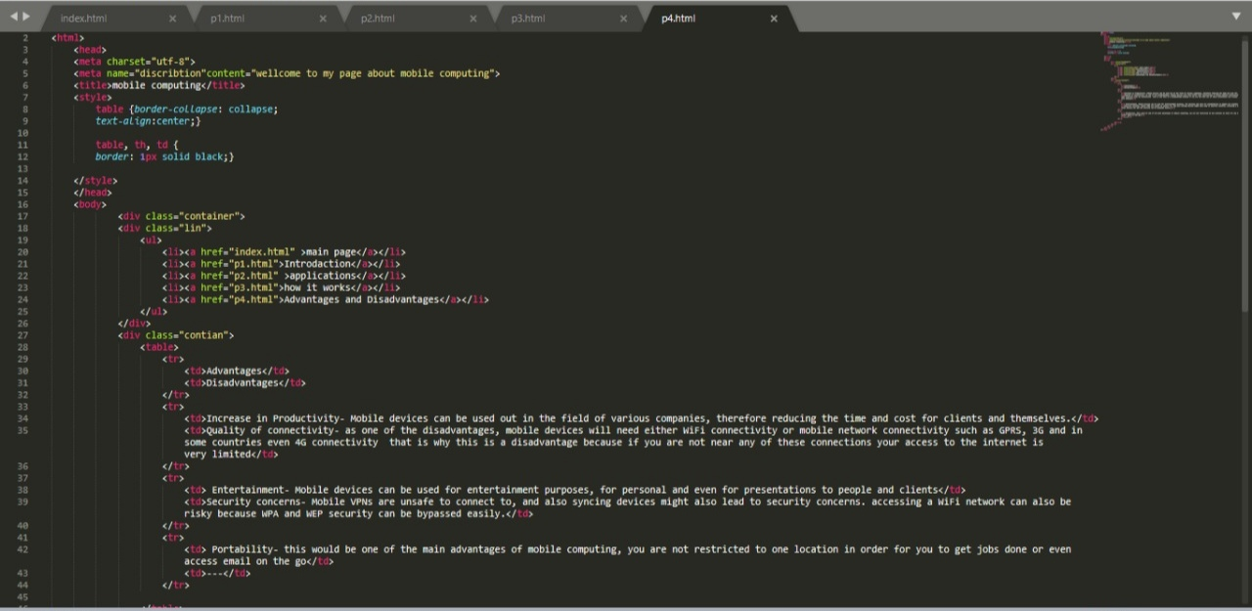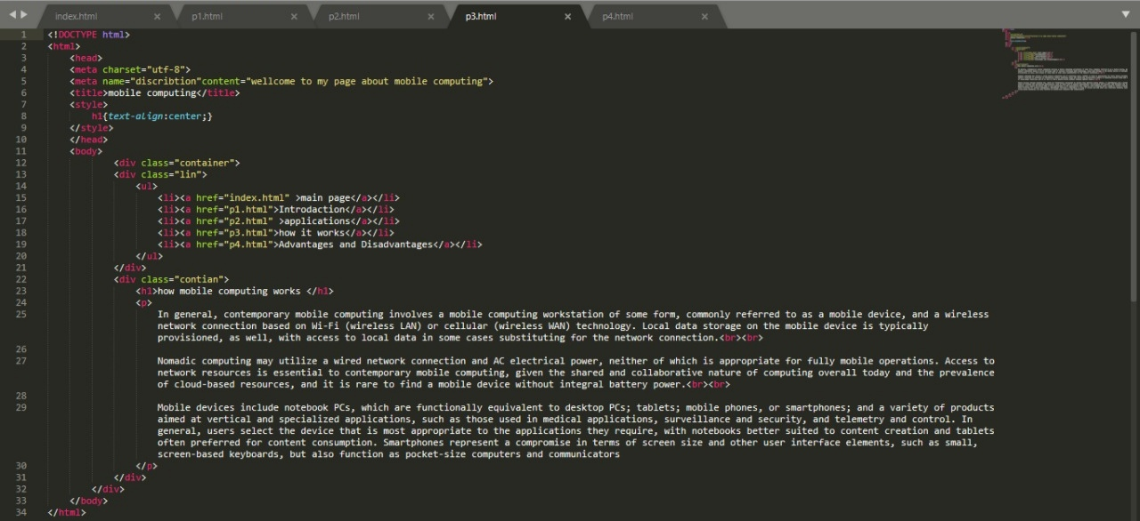

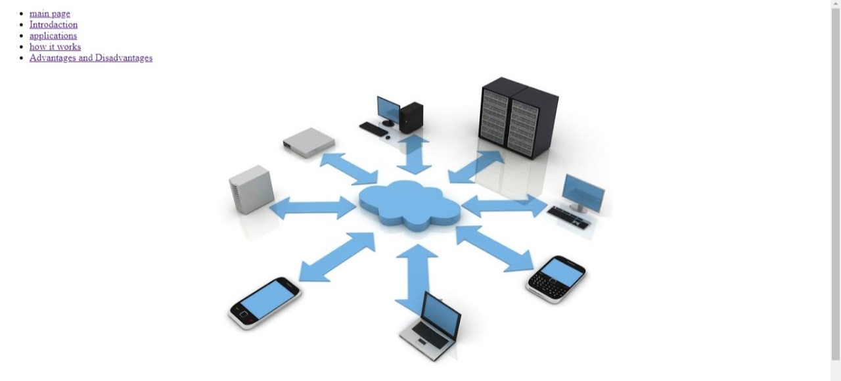

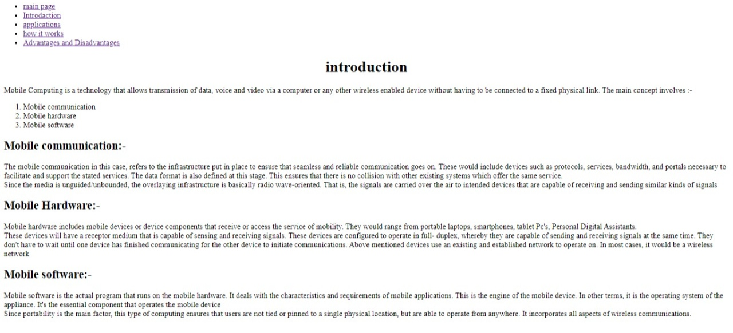

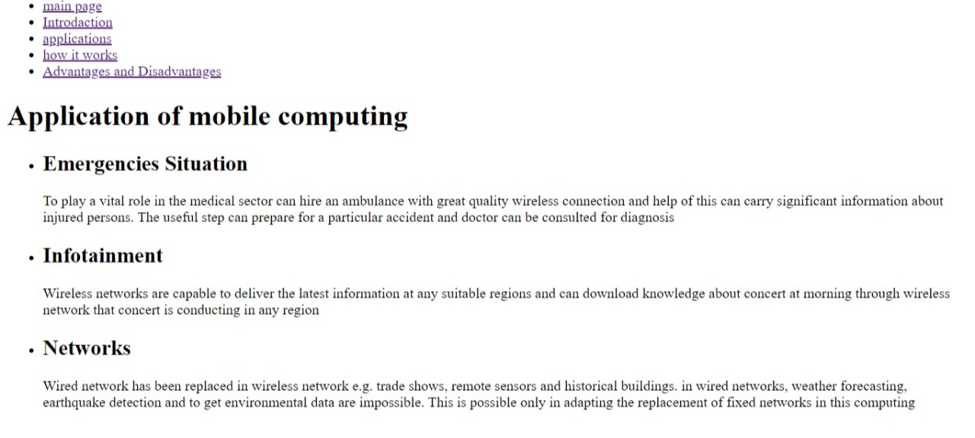

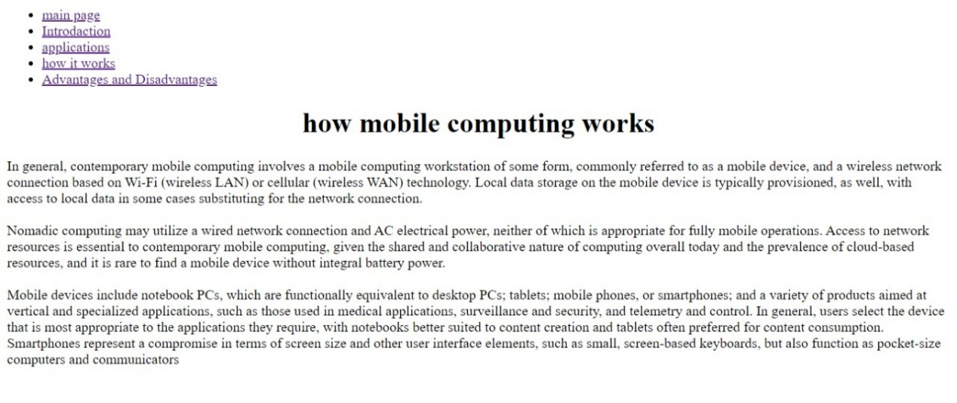

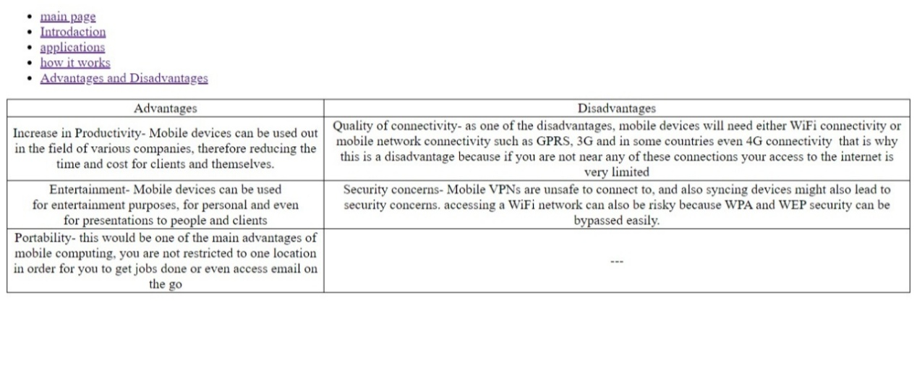

**References**

[**www.google.com**](http://www.google.com)

[**www.ekb.com**](http://www.ekb.com)